# **Write a C program to read marks of ‘n’ student and display using malloc ( ) function.**

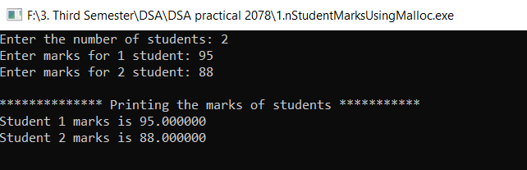

# **Write a C program to implement stack operations.**

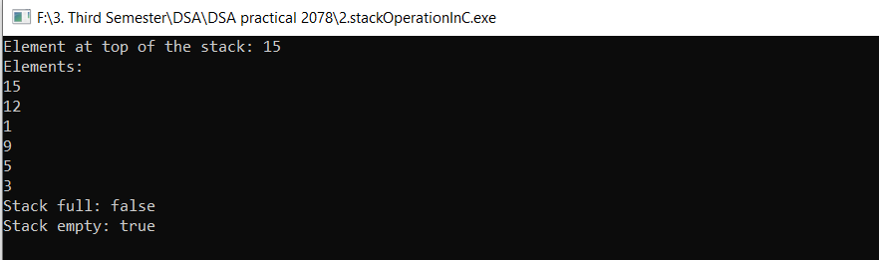

# **Write a C program to implement linear queue operations.**

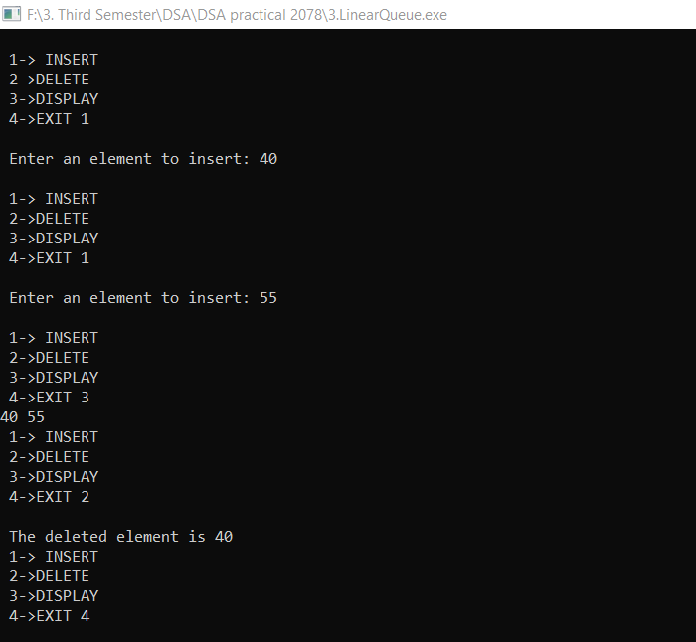

# **Write a C program to implement singly linked list operations.**

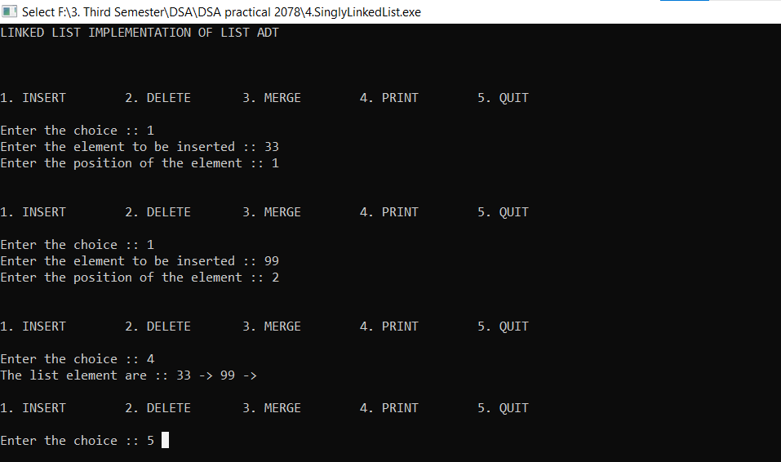

# **Write a C program to solve the problem of TOH(Tower of Hanoi).**

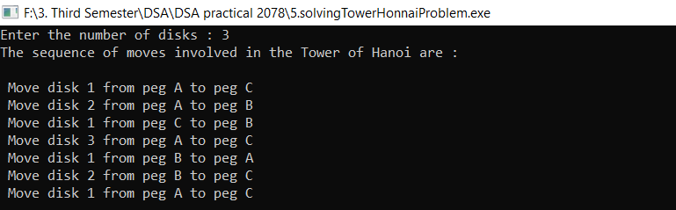

# **Write a C program to print Fibonacci series using recursive function.**

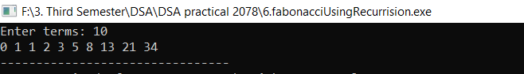

# **Write a C program to implement merge sort.**

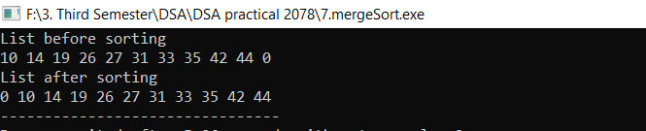

# **Write a C program to implement sequential search.**

